Learning Report – Embedded C



**Document History**

|  |  |  |  |  |  |
| --- | --- | --- | --- | --- | --- |
| **Ver. Rel.**  **No.** | **Release Date** | **Prepared. By** | **Reviewed By** | **Approved By** | **Remarks/Revision Details** |
|  |  | Katherapalle Rama Subba Reddy |  | Bhargav N |  |
|  |  |  |  |  |  |
|  |  |  |  |  |  |

## Contents

ACTIVITY 1 – COMPILATION APPROACH 4

1.1- MAKE FILE 4ERROR! BOOKMARK NOT DEFINED.

1.2- STARTUP CODE 5

1.3- LINKER FILE 8

1.4- DEBUGGING TECHNIQUES 9

ACTIVITY 2 – IMPLEMENTATION OF PROTOCOLS USING STM IDE 10

* 1. GPIO 10
  2. EXTI 12
  3. ADC 14
  4. SPI 16
  5. UART 19

**Activity 1 – COMPILATION APROACH**

This is the complete compilation process of the sample program for ARM Cortex Mx processor based boards.

Following are the compilation stages of a C program:

1. Preprocessor stage
2. Compilation stage
3. Assembly stage
4. Linking stage

## 1.1- MAKE FILE

Below is the make file for the sample program:

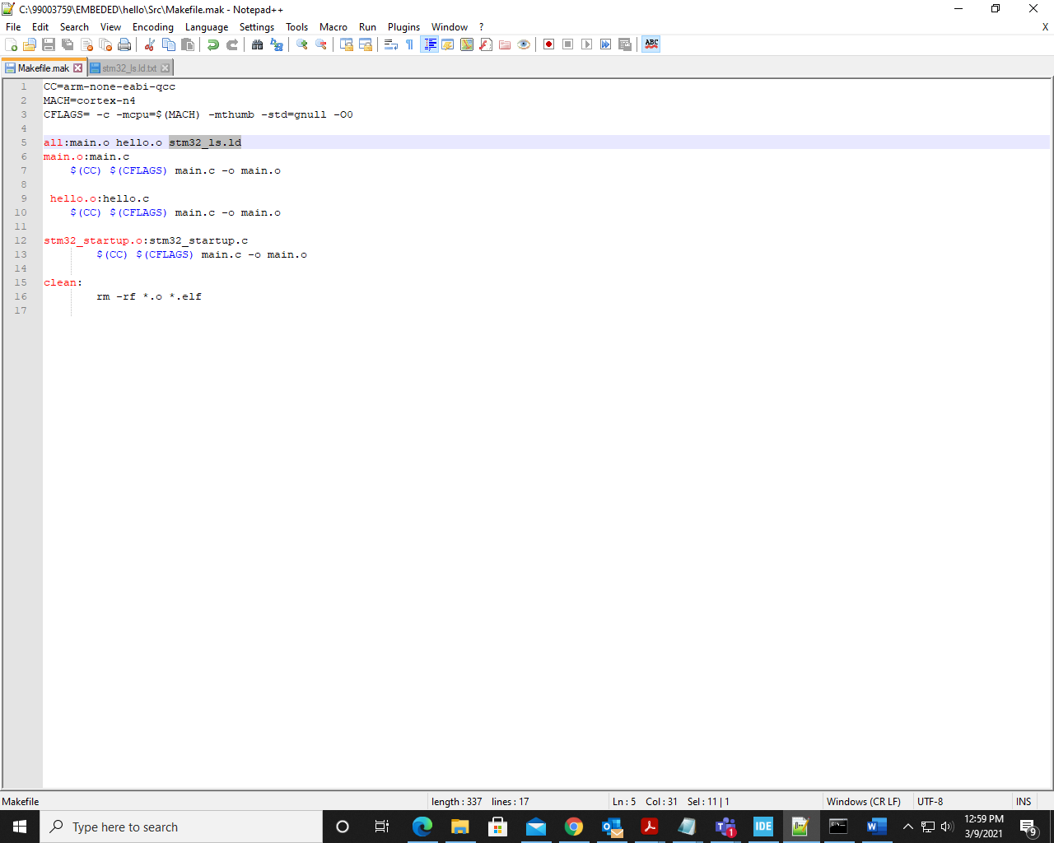

Fig 1.1.1 make file

The command to run this make file in the command prompt is:

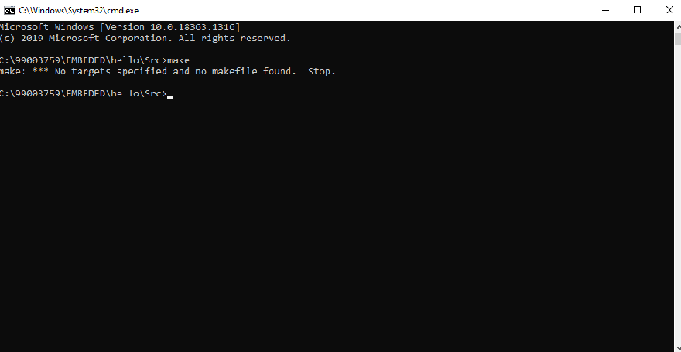

Fig 1.1.2 Make command

* + **-mcpu=cortex-m4** is used to select our cortex-m4 processor which is used
  + **-mthumb** is used to generate the code that executes in ARM state
  + **main.o** is the target file
  + **main.c** is the dependency

## 1.2- STARTUP CODE

* + The startup file is responsible for setting up the right environments to run the code in main.c file.
  + Some part of the startup code is target (processor) dependent.
  + Role of startup file:

1. Create a MCU specific vector table for microcontroller.
2. To write a startup code which initializes .data and .bss section in SRAM.
3. Call main()

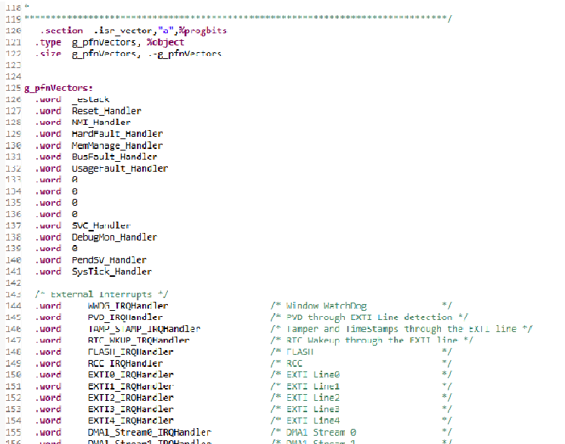

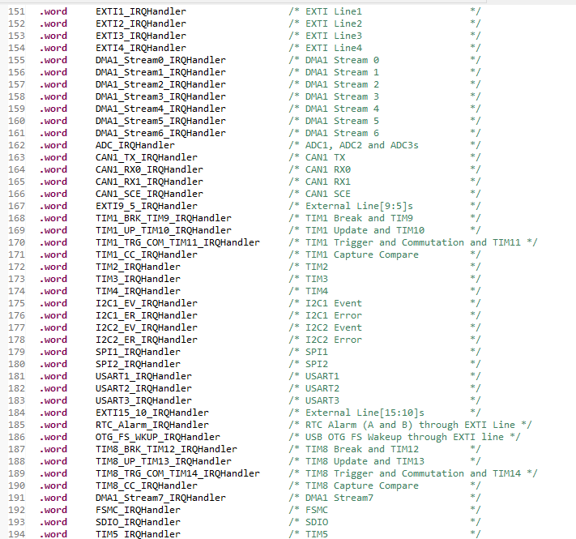

Fig 1.2.1 Startup code

In startup code we use variable attributes to store some variables in the user defined function. Function attributes:

* Weak: Lets programmer override already defined weak function (dummy function) with the same function name.
* Alias: Lets programmer give any alias name for same function.

The startup.o file generated is of elf executable format, various sections of which are shown below:

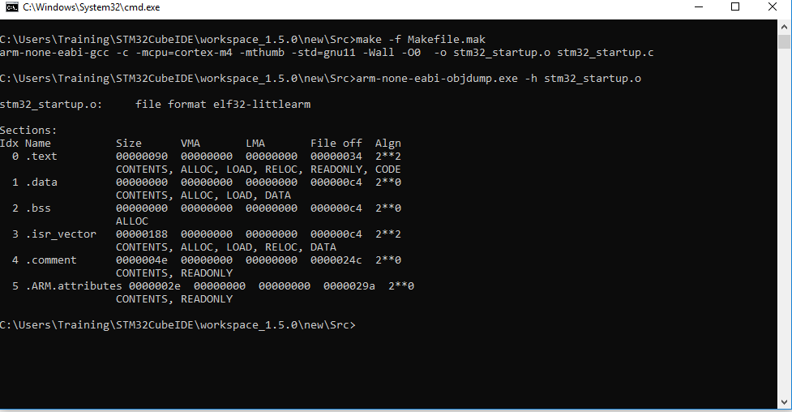

Fig 1.2.2: Startup command

## 1.3- LINKER SCRIPT

* + Linkers take one or more object files or libraries as input and combines them to create a single executable file as output.
  + Linker scripts decide how different sections of object file should be merged to create an output file.
  + Reset handler is the entry point to the application
  + Entry command is used to set the “Entry point address” information in the header of final elf file

generated.

Syntax: Entry(symbol_name) Entry(Reset_Handler)

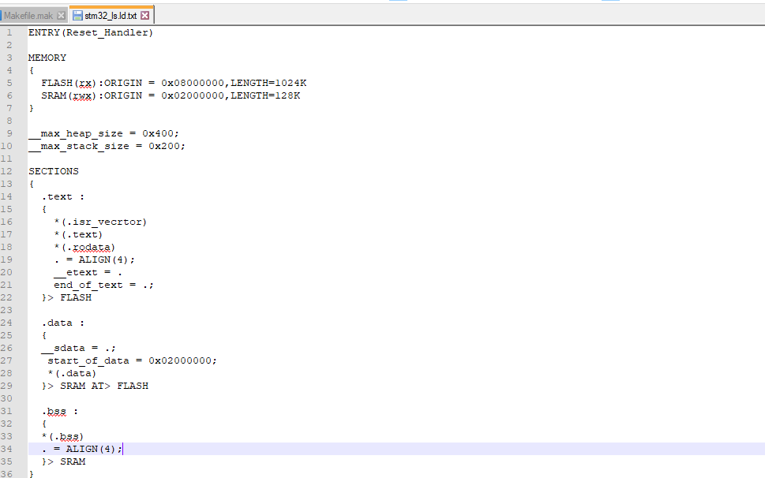

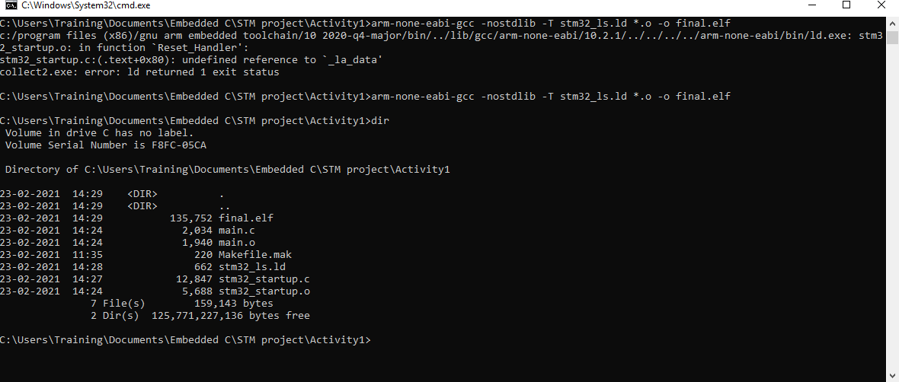

Fig 1.3.1 command to generate final.elf file

## 1.4- DEBUGGING TECHNIQUES

### The STM32F407VG is embedded with on chip debugger for debugging the code.

* + The OCD ON-Chip Debugger aims to provide debugging, in system programming and boundary scan testing for embedded target devices.
  + OCD is a free and opensource host application allows you to program, debug, and analyze your applications using GDB.
  + It supports various target boards based on different processor architecture.

# Activity 2 – IMPLEMENTATION OF PROTOCOLS USING STM IDE

### Implementation of protocols for STM32F407VG microcontroller featuring ARM32 bit ARM-cortex - M4 with FPU core using HAL library.

## GPIO:

Toggling LED at pin PD12 at GREEN_LED_GPIO_PORT. Serial wire is enabled at pin PA13.

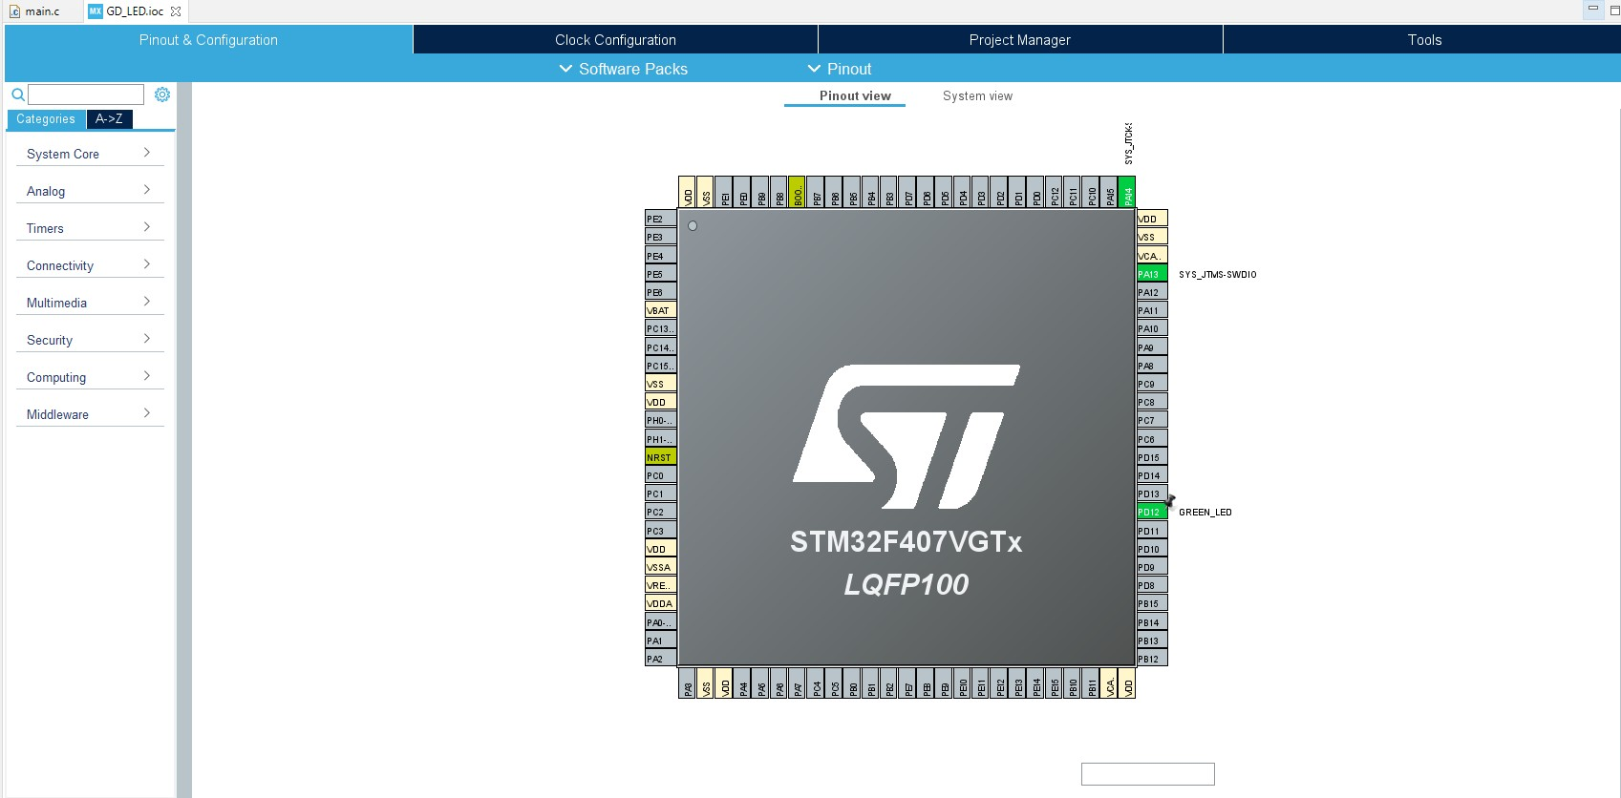

Fig: 2.1.1 GPIO pin configuration

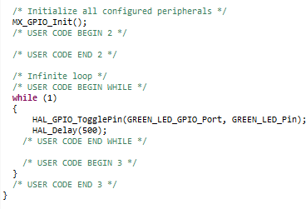

Fig: 2.1.2 GPIO configuration code

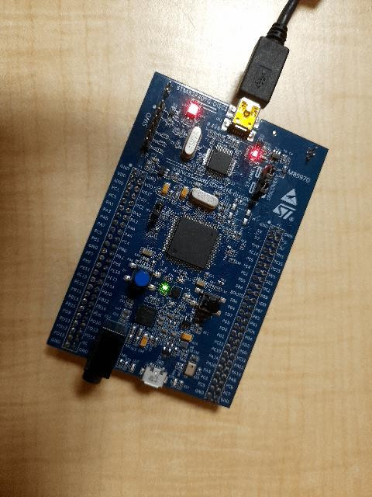

Fig: 2.1.2 LED toggling

## EXTI:

### Blue button at PA0 works as an external interrupt.

When the blue button is pressed the Green LED at pin PD12 toggles.

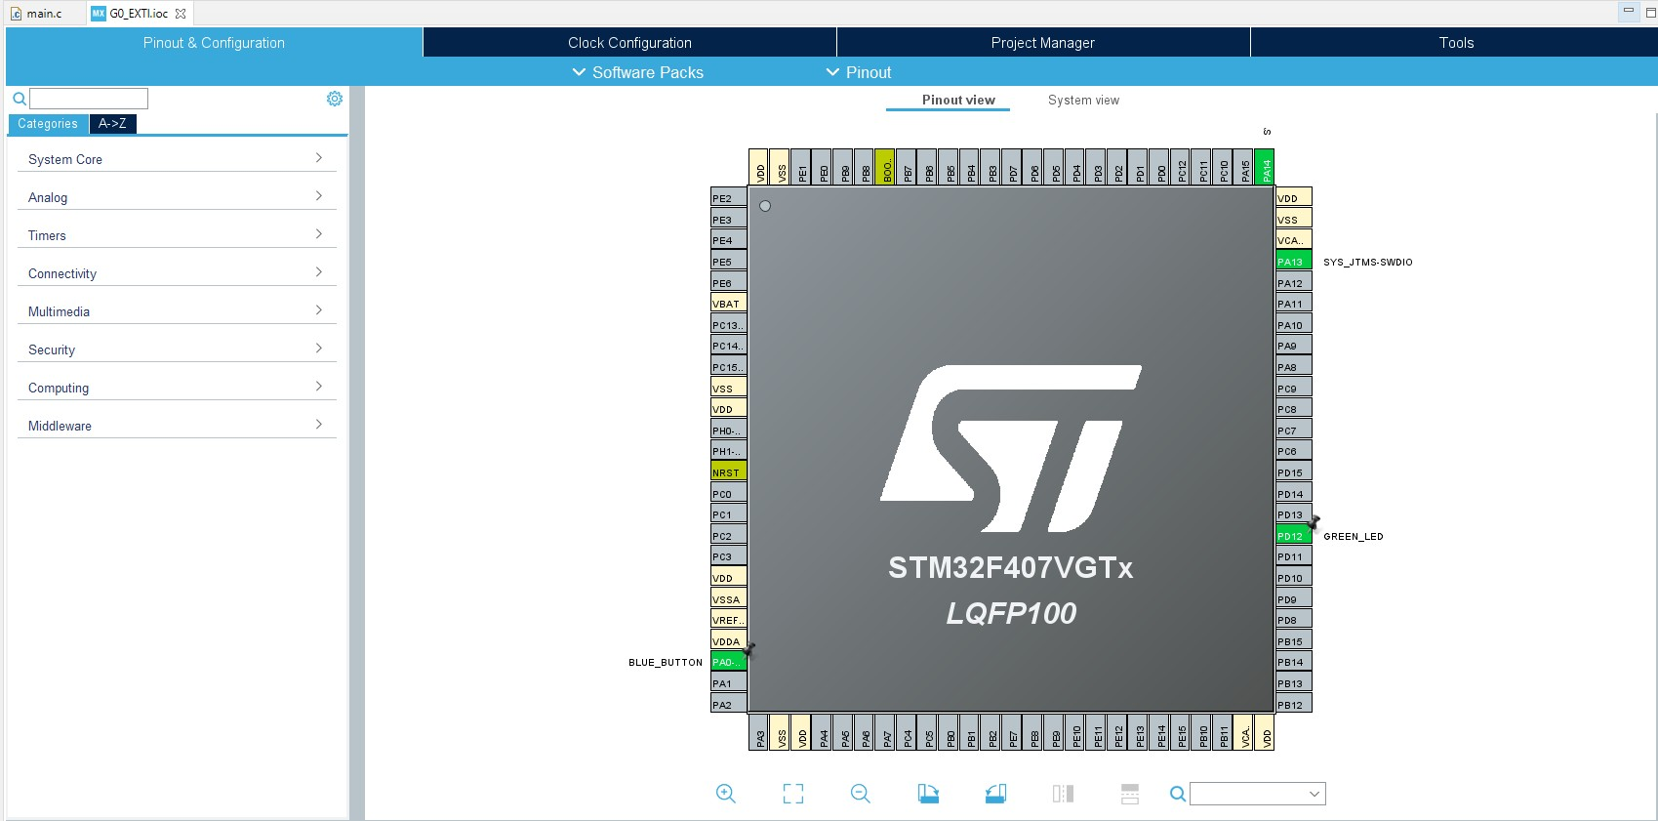

Fig: 2.2.1 EXTI pin configuration

### In the main.c file a flag is initialized and if the flag == 1, the condition under the if loop executed to toggle the LED at PD12.

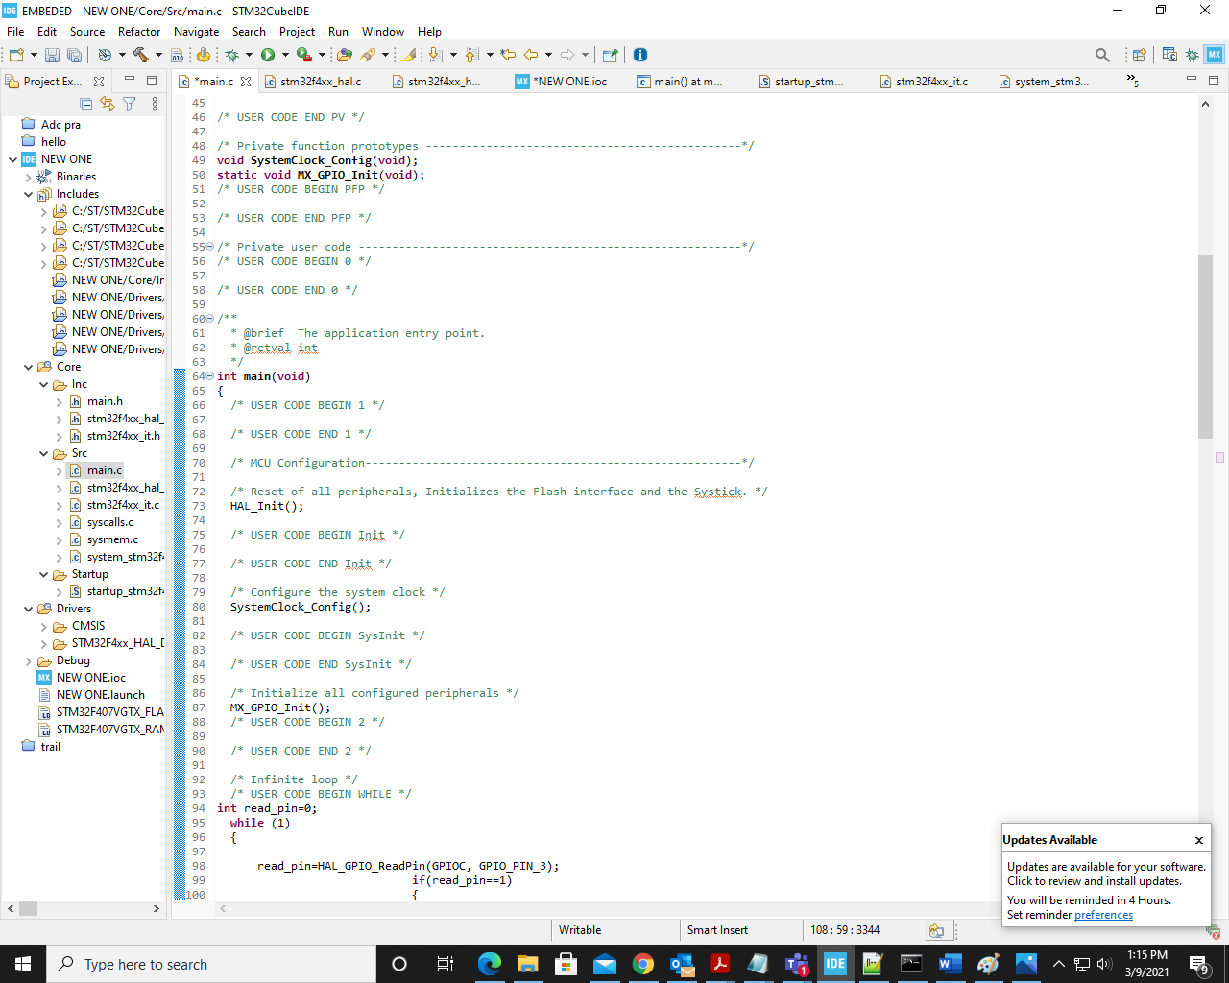

Fig: 2.2.1 EXTI configuration code

# ADC

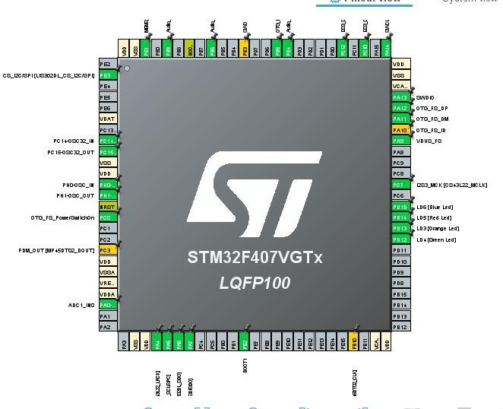

Fig: 2.3.1 ADC pin configuration

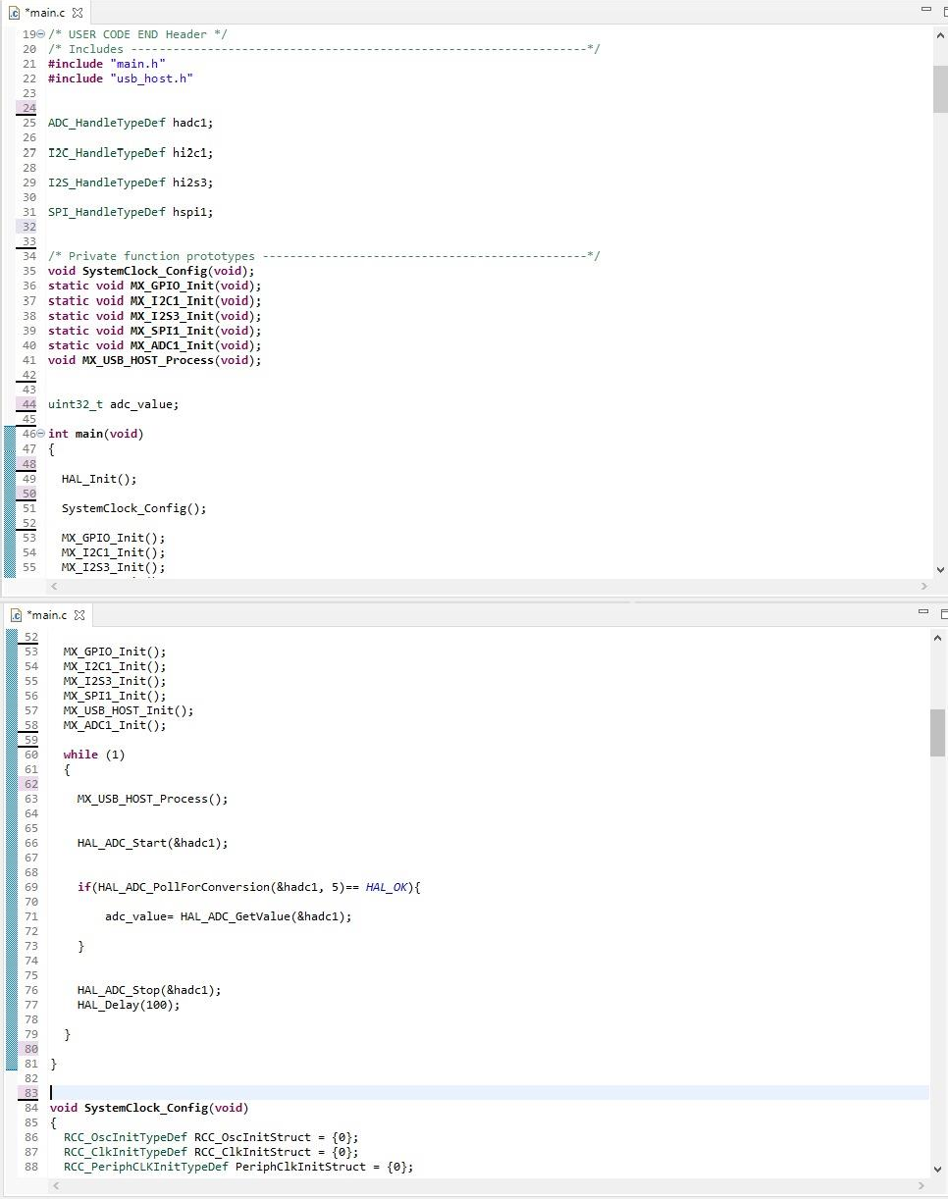

Fig: 2.3.2 ADC configuration code

# SPI

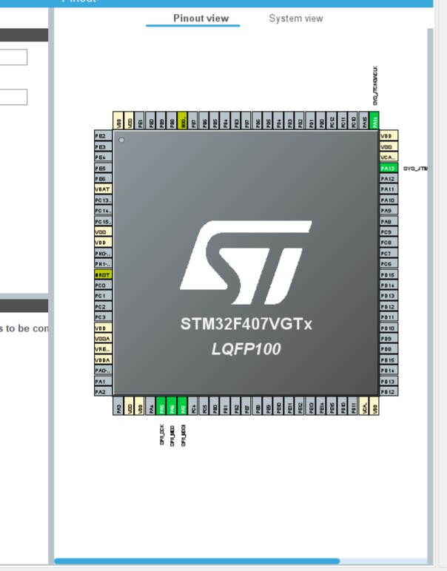

Fig: 2.4.1 SPI Pin configuration

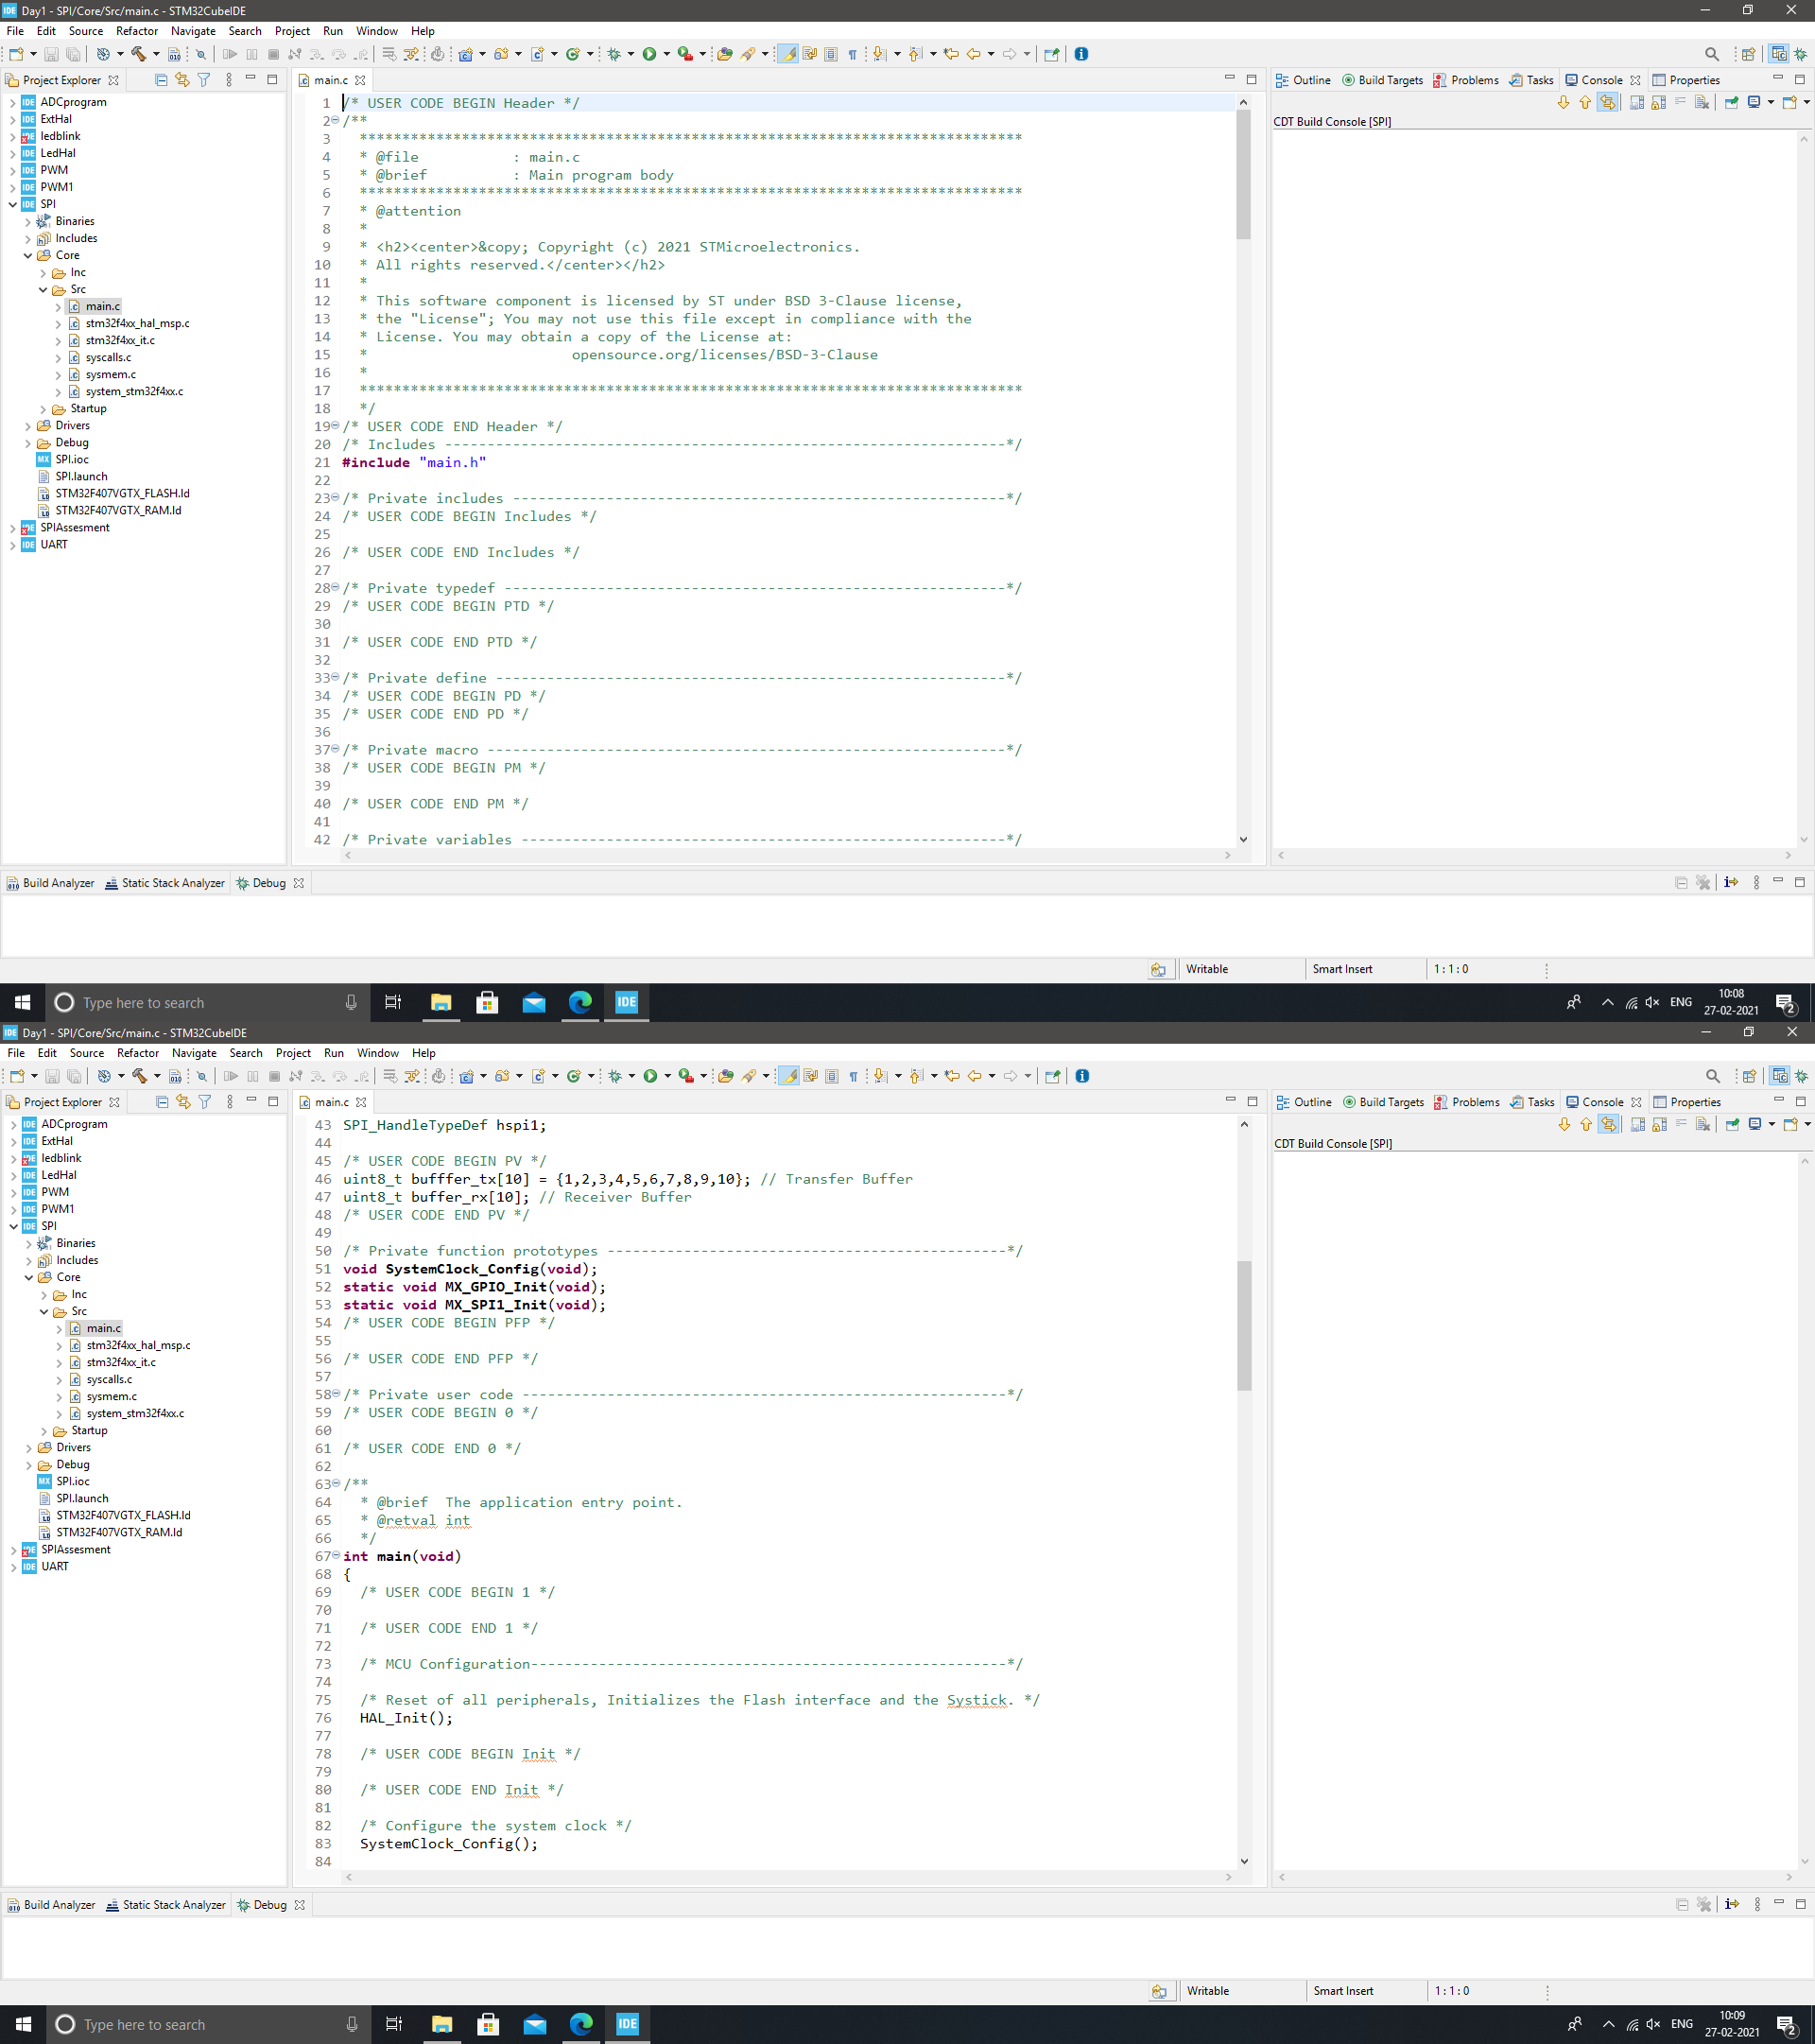

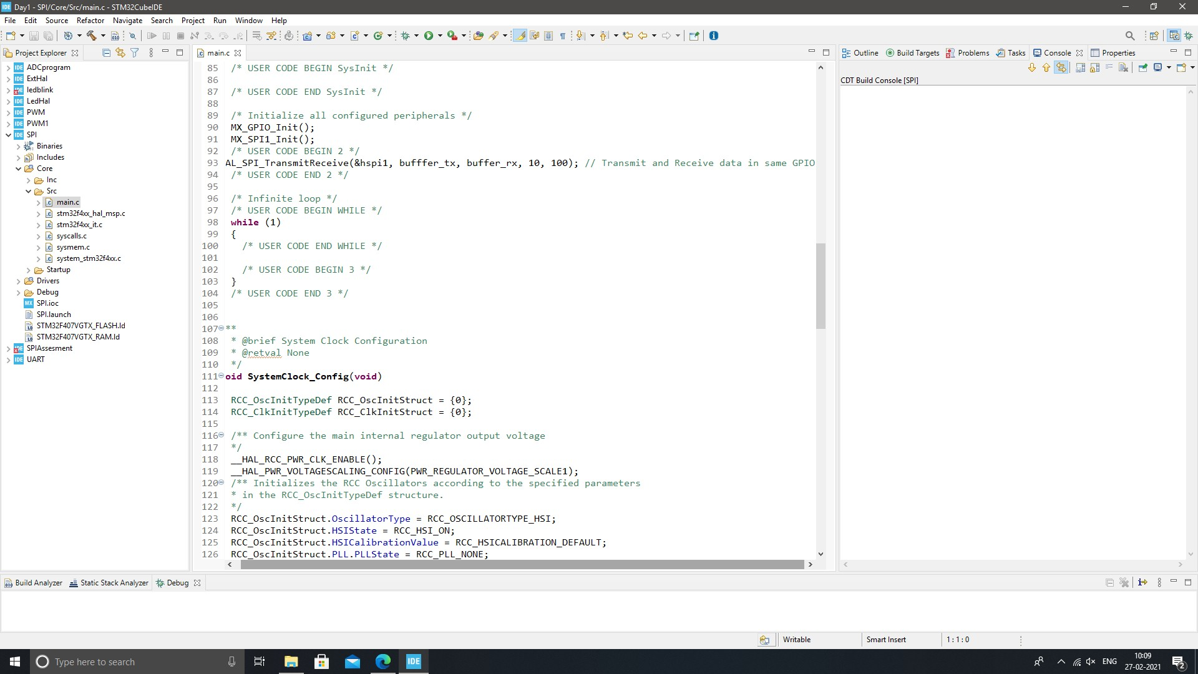

Fig: 2.4.2 SPI configuration code

# UART

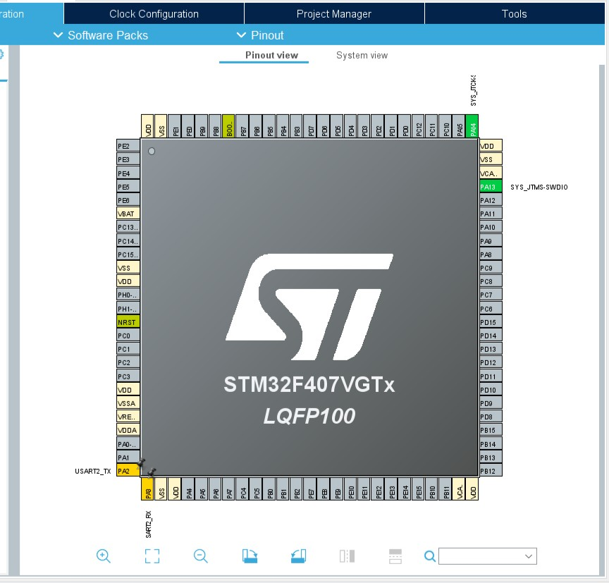

Fig: 2.5.1 UART Pin configuration

